**ASSIGNMENT 11**

1. Find the Minimum Marks and Maximum marks scored by each student.

|  |  |  |  |  |  |  |  |  |  |
| --- | --- | --- | --- | --- | --- | --- | --- | --- | --- |
| ROLL NO | NO OF STUDENT | SUB-1 | SUB-2 | SUB-3 | SUB-4 | SUB-5 | SUB-6 | MAX | MIN |
| 100101 | Rohan | 72 | 55 | 52 | 69 | 95 | 32 | 95 | 32 |
| 100102 | Mo han | 65 | 51 | 63 | 85 | 71 | 69 | 85 | 51 |
| 100103 | Ravi meheta | 72 | 56 | 78 | 85 | 47 | 68 | 85 | 47 |
| 100104 | Ruby tondon | 68 | 71 | 85 | 84 | 78 | 60 | 85 | 60 |
| 100105 | Radhika gupta | 80 | 78 | 58 | 65 | 68 | 45 | 80 | 45 |
| 100106 | Rakhi | 61 | 78 | 45 | 62 | 75 | 64 | 78 | 45 |
| 100107 | David | 78 | 69 | 96 | 52 | 63 | 87 | 96 | 52 |
| 100108 | mon ika mis hra | 96 | 85 | 86 | 84 | 45 | 63 | 96 | 45 |
| 100109 | Tommy singh | 75 | 63 | 54 | 63 | 61 | 98 | 98 | 54 |
| 100110 | p.rakesh | 63 | 52 | 96 | 87 | 78 | 45 | 96 | 45 |

1. Calculate the totals for each student, use conditional formatting to highlight the top students who have scored more than 400.

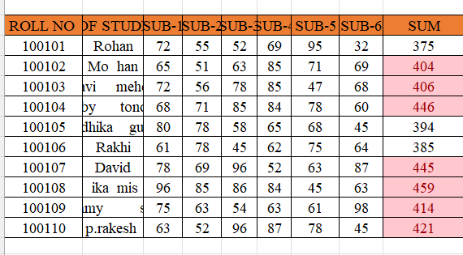

Calculate the length of the names of each student.

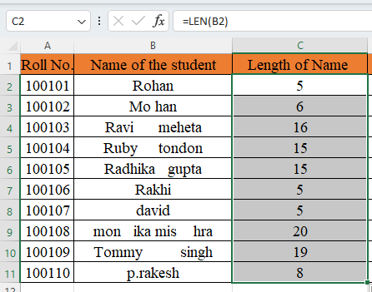

4. Replace the Name Rakhi with Rocky. Use Formulas

5. Combine the Roll Numbers and Names. Use formulas. The end result should look like below.

100101Rohan

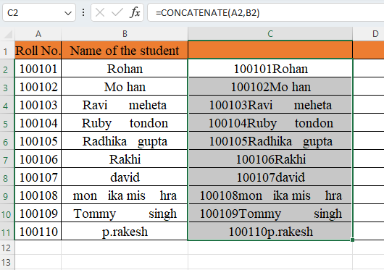

6. As you can see that some names have spacing issues. Use Formulas to correct that spacing. Also ensure that the names and surnames start with a capital letters



